**Adult Consent/Adolescent Assent for Participation in a Research Project**

**200 FR 2 (2017-1)**

**Robot Norm Violations during Human-Robot Interaction**

**Sarah Sebo, Shannon Yasuda, Sarah Wagner, David Shin**

**HSC #: 2000024240**

**Purpose:**

You are invited to participate in a research study designed to examine norms within human-robot interaction. You have been asked to take part because you are an English-speaker, 18 years or older.

**Procedures:**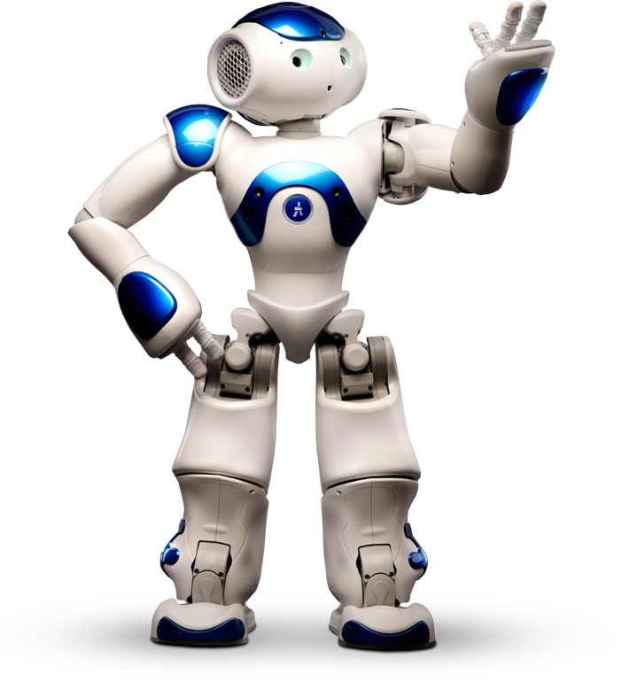

If you agree to take part, your participation in this study will involve interacting with a robot through several games of rock-paper-scissors. The robot you will be interacting with is called Nao. Nao is a small humanoid robot that is about 2 feet tall pictured on the right. Nao can speak and move its head, arms, and legs. You will also complete two surveys administered by a Yale-affiliated experimenter: a pre-survey asking about your experience with robots, interacting with a robot through several games of rock-paper-scissors and completing a post-survey about your experience interacting with the robot. We anticipate that your involvement will require 30 minutes You will receive $5 for your participation in this study.

**Videotaping:**

Videotaping will be a requirement for your participation in this study. We will use the tapes in order to evaluate your behavior during interaction with the robot to determine the influence of the robot.

All video data will be kept on a password protected hard-drive which will be locked in the Yale Computer Science Department. To protect your confidentiality, we will refer to participants in this study by a unique participant number rather than name. The names of participants will only appear on these forms, which will then be stored in a locked filing cabinet. Access to the footage and audio data will be limited to researchers working on this project.

**Risks and Benefits:**

You may experience slight discomfort in your interaction with the robot, but there are no other known or anticipated risks associated with this study. However, there is the possible risk of loss of confidentiality.  Every effort will be made to keep your information confidential; however, this cannot be guaranteed.

Although this study will not benefit you personally, we hope that our results will add to the knowledge about a robot’s perceived agency.

**Confidentiality:**

All of your responses will be held in confidence. Only the researchers involved in this study and those responsible for research oversight *(such as representatives of the Yale University Human Research Protection Program, and the Yale University Human Subjects Committee)* will have access to any information that could identify you. Your responses will be numbered and the code linking your number with your name will be stored in a separate locked file cabinet. When we publish any results from this study we will do so in a way that does not identify you unless we get your specific permission to do so. We may also share the data with other researchers so that they can check the accuracy of our conclusions but will only do so if we are confident that your confidentiality is protected. At the conclusions of this study, any identifying information related to your research participation will be destroyed, rendering the data anonymous.

**Voluntary Participation:**

Your participation in this study is voluntary. You are free to decline to participate, to end your participation at any time for any reason, or to refuse to answer any individual question without penalty. Refusing to participate will involve no penalty or loss of benefits or compensation to which you are otherwise entitled.

**Questions:**

If you have any questions about this study, you may contact the principal investigator, Sarah Sebo, at

sarah.sebo@yale.edu or (785) 580-6718.

If you would like to talk with someone other than the researchers to discuss problems or concerns, to discuss situations in the event that a member of the research team is not available, or to discuss your rights as a research participant, you may contact the Yale University Human Subjects Committee, 203-785-4688, *[Add country code if applicable]* [human.subjects@yale.edu](mailto:human.subjects@yale.edu). Additional information is available at <http://your.yale.edu/research-support/human-research/research-participants>

**Agreement to Participate:**

I have read the above information, have had the opportunity to have any questions about this study answered and agree to participate in this study.

_________________________________            _____________

(printed name)                                                          (date)

_________________________________

(signature)

**(Optional) Agreement for Video Recording Use Beyond This Study and in Research Presentations:**

I allow video recordings of myself to be used in research presentations and kept permanently for research purposes to further analyze and understand the dynamics of social interactions between people and robots.

_________________________________            _____________

(signature)                                                                (date)

**(Optional) Agreement to Join Mailing List for Future Study Recruitment:**

I allow members of the Social Robotics Lab to contact me via my email address to ask for my participation in future studies conducted by the Social Robotics Lab.

_______________________________________________________

(email address)

_________________________________            _____________

(signature)                                                                (date)